Hezekiah and the Great Assyrian Threat
A Dramatic Monologue
2 Kings 18-19
Pastor Steve Newman

Introduction to Hezekiah: “In the third year of Hoshea son of Elah king of Israel, Hezekiah son of Ahaz king of Judah began to reign. He was twenty-five years old when he became king, and he reigned in Jerusalem twenty-nine years. His mother’s name was Abijah daughter of Zechariah. He did what was right in the eyes of the Lord, just as his father David had done. He removed the high places, smashed the sacred stones and cut down the Asherah poles. He broke into pieces the bronze snake Moses had made, for up to that time the Israelites had been burning incense to it. (It was called Nehushtan.) Hezekiah trusted in the Lord, the God of Israel. There was no one like him among all the kings of Judah, either before him or after him. He held fast to the Lord and did not stop following him; he kept the commands the Lord had given Moses. And the Lord was with him; he was successful in whatever he undertook.” (2 Kings 18:1-7a)

Have you ever felt yourself caught in an impossible situation, a situation so far gone that there was no way out? I am going to tell you about a situation that I was in that was so horrible that it looked like there was no way out for me and my people. I was feeling desperate and my people were definitely desperate, but God provided a way out. If you are facing a difficulty today, I want you to listen to my story and learn. I think God has a message for you today.
I am Hezekiah, son of Ahaz, King of Judah. From an early age, I determined to go a different course from my father Ahaz. He turned from the Law of Moses and looked to the idolatrous kings of Israel, the confederation of northern tribes, as his patterns for religious observance. As a result he worshiped pagan gods and even went so far as to sacrifice one of my brothers to one of these gods. Can you imagine what has to happen to a parent so that he has his own son killed as a sacrifice? Then he did wrong when threatened by a coalition of Israel and Syria who were threading his kingdom. Instead of trusting in the Lord, he trusted in Tiglath-Pileser, the king of Assyria, to solve the military threats he encountered from these neighbors to the north. This trust seemed to work, but led to more problems for Judah. When my father went to Damascus to meet Tiglath-Pileser, he became enamored with a pagan altar he saw there. So he had a pagan altar built like one he had seen in Damascus and had it replace the altar to the Lord at the temple in Jerusalem. This was my heritage from my father - pagan idolatry, rebellion against the Lord, abandoning God’s ways for things more in line with what the other people around us were doing.
I determined that I was not going to be like my father. I wanted to be like Joshua of old who said, “As for me and my house, we will serve the LORD.” So when I became king, I took steps to turn our people back to the Lord. I smashed the pagan idols and cut down the poles dedicated to Baal’s consort Asherah, a pagan goddess. The people had been worshiping the Lord at their own altars on various hills and high places. This was because of pagan influences. The hills were supposed to be closer to the gods and therefore better for worship. But the Law of Moses said that we were only to worship at the central sanctuary, which was first the tabernacle and then the temple. I removed the high places where the Lord was worshiped on the hills. It took courage to reject the pagan ways and to dedicate our people to once again follow the LORD. These were dangerous times and many thought that we could anger the gods (which were false gods) or get in trouble with the big super power Assyria if we threw out the pagan worship.
In my fourth year, the Assyrians attacked Israel, the kingdom of the northern tribes, and besieged its capital, Samaria. The siege lasted three horrible years, but the Assyrians starved them out, captured the city and deported the people. It was a terrible time of suffering. Needless, too. If they had followed the Lord and kept his Law, all this destruction would not have happened. The Hebrew historian rightly said why this took place: “This happened because they had not obeyed the Lord their God, but had violated his covenant—all that Moses the servant of the Lord commanded. They neither listened to the commands nor carried them out.” (2 Kings 18:12)
We of Judah, the southern kingdom of Israelite people, were anxious when the northern kingdom fell to the Assyrians, but we were spared from trouble when the Assyrian army left our territory. But underlying our time of peace, many were worried that the Assyrians would come back to our land.
Seven years later, during my fourteen year of reign, the problem of Assyria came to us. Sennacherib king of Assyria attacked all the fortified cities of Judah and captured them - over forty of them! Only Jerusalem was left. You can imagine how frightened we all were. The people were desperate and wanted me to do something different. Anything so that we would not have to suffer through a slow siege and starvation like Samaria had suffered.

Lachish was the best fortified city besides Jerusalem.
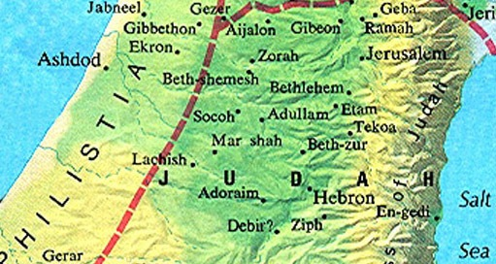

Rendering of the fortified city of Lachish:

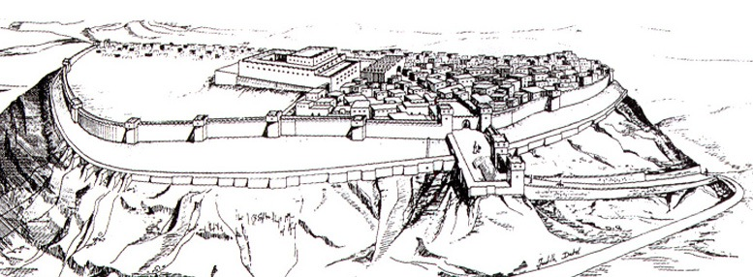

Sennacherib celebrated this victory and others on bas relief carvings on stone in his official records.

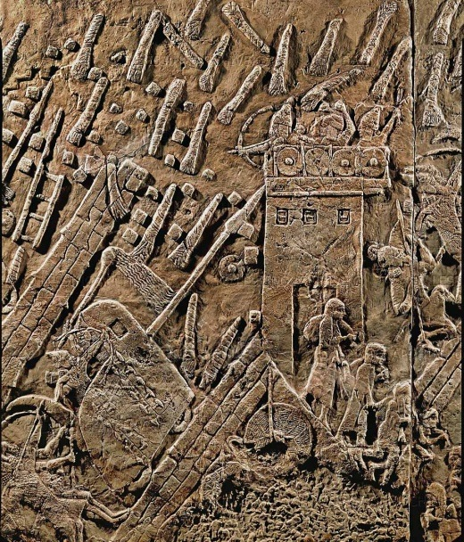

From Lachish he sent some of his chief officials to me at Jerusalem to try to get me to capitulate. He wanted to hurry the completion of his victory and not have the delay of another lengthy siege.
Sennacherib’s officials spoke to some of my officials and told them to give me this message: “‘This is what the great king, the king of Assyria, says: On what are you basing this confidence of yours? You say you have the counsel and the might for war—but you speak only empty words. On whom are you depending, that you rebel against me? Look, I know you are depending on Egypt, that splintered reed of a staff, which pierces the hand of anyone who leans on it! Such is Pharaoh king of Egypt to all who depend on him. But if you say to me, “We are depending on the Lord our God”—isn’t he the one whose high places and altars Hezekiah removed, saying to Judah and Jerusalem, “You must worship before this altar in Jerusalem”? Come now, make a bargain with my master, the king of Assyria: I will give you two thousand horses—if you can put riders on them! How can you repulse one officer of the least of my master’s officials, even though you are depending on Egypt for chariots and horsemen? Furthermore, have I come to attack and destroy this place without word from the Lord? The Lord himself told me to march against this country and destroy it.’” (2 Kings 18:19-25)
They were being tricky and trying to make my people be afraid not to surrender to them. It took them three years to wear down the people of Samaria with a siege and they did not want to have to take such a long time to conquer us. So they spoke about the futility of trusting in the Egyptians to protect us from them. They were the great power to the south and the only human option for opposing the Assyrians. They spoke against trusting in the Lord as if that were also futile. I told you that I had torn down the illegal high places and altars that were dedicated to the Lord outside of Jerusalem and now these Assyrians were trying to make my people afraid that we had offended the Lord. Then they had the gall to claim that the Lord had told them to come conquer us and that resisting them would be resisting the Lord.
What would you do in such a case? Would you give in? Would this seem like the practical thing to do? The people were desperate. I knew that they thought I was crazy. How could we have any chance of successfully resisting the Assyrians? They had a huge army with tens of thousands of soldiers. They had already captured every one of the other cities of Judah. Only Jerusalem was left.
To make matters worse, these Assyrian officials spoke not only to my officials but to all the people who could hear them shouting to them in the Hebrew language in an attempt to turn them from me and from trusting in God. I was hoping that their threats and their offers would be made in private for me and my officials to respond to. But no! They were made loudly in Hebrew so that all the people could hear.
Then the commander stood and called out in Hebrew, “Hear the word of the great king, the king of Assyria! This is what the king says: Do not let Hezekiah deceive you. He cannot deliver you from my hand. Do not let Hezekiah persuade you to trust in the Lord when he says, ‘The Lord will surely deliver us; this city will not be given into the hand of the king of Assyria.’ Do not listen to Hezekiah. This is what the king of Assyria says: Make peace with me and come out to me. Then each of you will eat fruit from your own vine and fig tree and drink water from your own cistern, until I come and take you to a land like your own—a land of grain and new wine, a land of bread and vineyards, a land of olive trees and honey. Choose life and not death!” (2 Kings 18:28-32)
This was just getting worse and worse. Their offers of peace sounded so good - each with his own vine and fig tree, but I knew that they were not being truthful with us. I did not want to give in to fear, no matter how bad the situation got. I did not want to become unfaithful to the Lord just because the situation seemed humanly hopeless. What could I do? When my officials told me what had happened, I tore my clothes and put on sackcloth and sent for Isaiah the prophet.
Isaiah said to them, “Tell your master, ‘This is what the Lord says: Do not be afraid of what you have heard—those words with which the underlings of the king of Assyria have blasphemed me. Listen! When he hears a certain report, I will make him want to return to his own country, and there I will have him cut down with the sword.’” (2 Kings 19:6-7)
These words sounded good, but how could these things be? Would the Assyrians really leave us? I was trusting the Lord, but this was getting very hard!
Sennacherib again sent messengers to me with this word: “Say to Hezekiah king of Judah: Do not let the god you depend on deceive you when he says, ‘Jerusalem will not be given into the hands of the king of Assyria.’ Surely you have heard what the kings of Assyria have done to all the countries, destroying them completely. And will you be delivered? Did the gods of the nations that were destroyed by my predecessors deliver them—the gods of Gozan, Harran, Rezeph and the people of Eden who were in Tel Assar? Where is the king of Hamath or the king of Arpad? Where are the kings of Lair, Sepharvaim, Hena and Ivvah?” (2 Kings 19:10-13)
When I received the letter from the messengers and read it, I went up to the temple of the Lord and spread it out before the Lord. And I prayed to the Lord: “Lord, the God of Israel, enthroned between the cherubim, you alone are God over all the kingdoms of the earth. You have made heaven and earth. Give ear, Lord, and hear; open your eyes, Lord, and see; listen to the words Sennacherib has sent to ridicule the living God. It is true, Lord, that the Assyrian kings have laid waste these nations and their lands. They have thrown their gods into the fire and destroyed them, for they were not gods but only wood and stone, fashioned by human hands. Now, Lord our God, deliver us from his hand, so that all the kingdoms of the earth may know that you alone, Lord, are God.” (2 Kings 19:15-19)
Isaiah told me the Lord’s response: “Therefore this is what the Lord says concerning the king of Assyria: ‘He will not enter this city or shoot an arrow here. He will not come before it with shield or build a siege ramp against it. By the way that he came he will return; he will not enter this city, declares the Lord. I will defend this city and save it, for my sake and for the sake of David my servant.’” (2 Kings 19:32-34)
This was unbelievably good news! I did not know how this could be fulfilled, but I believed the word of God’s prophet Isaiah. That night the angel of the Lord went out and put to death a hundred and eighty-five thousand in the Assyrian camp. 185,000!!! When the people got up the next morning—there were all the dead bodies! So Sennacherib king of Assyria broke camp and withdrew. He returned to Nineveh and stayed there. Some time later we found out that Sennacherib was killed after he returned to his land, just as Isaiah had said. One day, while he was worshiping in the temple of his god Nisrok, his sons Adrammelek and Sharezer killed him with the sword, and they escaped to the land of Ararat. And Esarhaddon his son succeeded him as king.
You cannot imagine how surprised and how relieved we were when we found that all those soldiers had been killed and that the Assyrians had withdrawn. I was determined to lead the people by trusting in the Lord and not giving in to fear. Many thought that I was crazy. Many thought that I was not being practical. How could we hope that God would send an angel to strike dead so many Assyrian soldiers? Could we believe that God would do the impossible?
Some of you are facing huge challenges in your life. Oh, they are not like my challenge, but I am hoping that you can take courage from mine. Your friends may be telling you to get practical and stop trusting God. They may be pointing out the great powers that are against you. You might not have the threat of Assyrians, but maybe you will have economic threat. Will you cheat and steal to get what you need or trust God? Will you break laws or compromise your principles and abuse other people to make sure you get enough for yourself or will you trust God?
Maybe you have the threat of the call of obedience. Will you be faithful in service to God with your time and your money even if this threatens your lifestyle and means life is not just about you and your comfort? Will you give in to the pagan ways just because your neighbors are doing these things? That is what my father Ahaz did. You may be tempted to worship the idols of your world, things like pleasure, money and power. You let these become valued like gods and let them tell you what to do and how to live your life instead of getting your directions from God himself.
Maybe you have challenges in your home. Your marriage is difficult and you are tempted to flee. You are tired of your problems and you want to just get away from them. Trust God. Don’t give up. Trust him to find answers for you. Believe from my story that God can do the impossible for his people.
As the great King Solomon said, “Trust in the Lord with all your heart and lean not on your own understanding; in all your ways submit to him, and he will make your paths straight.” (Proverbs 3:5-6)

Narrator: “Now to him who is able to do immeasurably more than all we ask or imagine, according to his power that is at work within us, to him be glory in the church and in Christ Jesus throughout all generations, for ever and ever! Amen.” (Ephesians 3:20-21)

